 School Counseling Program Newsletter
Shandrai Silva, School Counselor | December 2017

Counselor Message  Happy December! I am excited about the beginning of a new month at Hawks Nest STEAM Academy. I am especially excited about this time of the year - a time of celebration, reflection and giving.  Last month, the school counseling program was offered classroom guidance lessons from Strong Start Social Emotional Learning and in Digital Citizenship. Small group counseling is underway as students focus on social skills and coping skills  As a school, we participated in a school-wide service project by collecting food for two helping organizations. We collected over 500 food items! There is a picture below. Thank you so much for supporting this effort.  November 7th was Election Day. Students in grade 3-5 voted on Student Council officers. Class representatives were also elected in November. Our newly elected Student Council members are excited and ready to serve! I can’t wait to work with them.  I can’t wait to see what the 2nd half of the school year has to offer!  _______________________   | Home of the Hawks    GCS Day of Kindness  December 6th- Wear pink to  show your commitment to  kindness & make an effort to  to be extra kind on this day.  Bucket-filling Opportunity    For every Santa letter received, Macy’s  Department store will donate $1 to the  Make-A-Wish®, up to $1 million, to  grant the wishes of children with  critical illnesses. National Believe Day  is Friday, December 8th. For more  information, see  https://www.macys.com/social/believe/make-a-  wish/?cm_sp=imp-_-believe-_-hamnav_makeawish  https://www.macys.com/social/believe  How to see the school counselor  Classroom guidance classes are weekly based on grade level specials schedule. Small group counseling and individual counseling by self -referral, parent referral, teacher referral, administrator referral or counselor initiated. Contact School Counselor at 704-866-8467 or sosilva@gaston.k12.nc.us. | Character Education  “We’re Soaring with Good Character”  ______________________________  The character trait of the month is Kindness. Kindness is being caring and showing concern and compassion for others.  ______________________________________________  Promoting Character Education  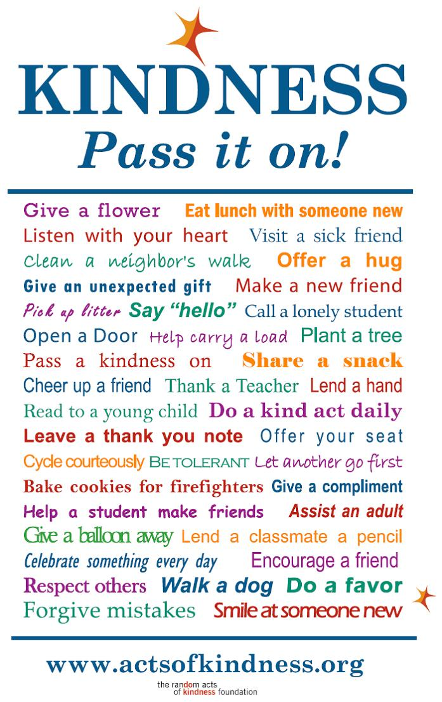  https://volunteeruwsn.files.wordpress.com/2011/01/rak_pass_it_on1.jpg  

